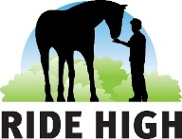
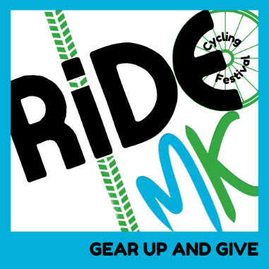

Booking Terms and Conditions (the Terms)
General Terms (which include an indemnity)
1.By paying the registration fee you are registering your place on the Ride MK Cycling Festival (the Event) organised by Ride High Ltd (the organiser) and aim to raise funds for the charity Ride High. Fundraising targets per participant are as follows (please note we won’t hold you to this, every penny counts):
- 100 km road route – £150
- 50 km road route – £100
- 25 km red route – £75
- Ready Set Go route – £50
3. Should the Event be unable to take place due to Force Majeure, bad weather or any other cause that affects the safe operation of the Event no refunds shall be made by Ride High. Instead, the Event will be rescheduled. If you are unable to take part on the rescheduled date then you will have the option to complete the Event virtually. Force Majeure is any event or circumstances which Ride High could not, even with all due care, foresee or avoid including actual or threatened war, riot, civil strife, national emergency, terrorist activity, industrial dispute, prohibitive government regulations, pandemic, natural or nuclear disaster, adverse weather conditions, fire and all other events beyond the reasonable control of Ride High.
4. The minimum age for participants of each route is:
- 100 km road route – 16 years. Those under 18 require consent from a parent or guardian.
- 50 km road route – 16 years. Those under 18 require consent from a parent or guardian.
- 25 km red route – any age but children under 18 years need consent from a parent or guardian and children under 16 years need to be accompanied by an adult at all times.
- Ready Set Go route – 0-12 years. All participants need to be accompanied by an adult at all times.
5. Photography and filming may take place at the Event to be used for promotional material. Please inform Ride High before the event if you do not wish to feature.
6. Whilst taking part in this event you must:
• wear a cycle helmet at all times;
• ensure that your bicycle is in a roadworthy condition;
• observe the rules of the Highway Code.
Medical Restrictions
You should be suitably fit to take part in event and you are strongly advised to undertake some training. If you have any doubts about your ability to take part including having pre‐existing medical conditions you should contact your doctor to seek advice.
IMPORTANT NOTICE AND DISCLAIMER OF LIABILITY
I hereby certify that I (or the child I am providing consent for) am/is fit and healthy enough to participate in the Event and my/their cycle is in a safe, legal and roadworthy condition. Cycling is an active sport and participation in such sports necessarily involves a risk of injury or death regardless of the standard of the organisation of the event you are taking part in. I voluntarily accept all the risks inherent in this event and I agree for myself to indemnify and hold harmless Ride High against any claim or claims whether on my own account or from third parties arising out of any accident or incident resulting in any loss or damage (including bodily injury and death). I confirm I have read all the sections of these Terms, and I understand and agree to be bound to those terms and conditions and to comply fully with the same.

